NEL LAPAS & KONSTRUKSIE

Gras groei nie onder ons voete nie!

**Comb and repairs on thatched roofs.**

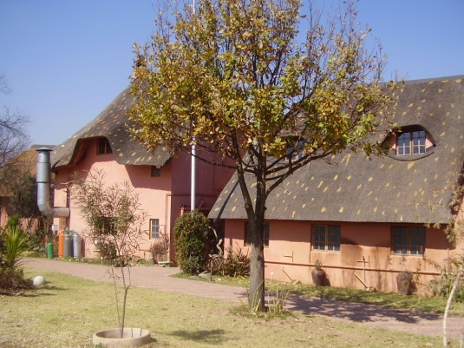

* Thatch roof construction and thatching of new houses, lodges and lapas.
* Extensions on existing thatched roofs and thatched roof repair.
* Replacement of any rotten standing pole, broken of cracked ring beams and trussers without removing the thatch.
* Combing and patching of any kind of thatched roof as well as general thatch roof maintenance and repair.
* Comb and thatch a 120 mm layer of new grass over the existing roof.
* Remove old thatch roofs and re-thatch on existing construction.
* Removing of grass and cement ridging and replacing it with fibre glass ridging on top of the thatched roofs. If maintained properly it will last forever.

**We will beat any written quotation of a registered company on comb and general repairs on lapas.**

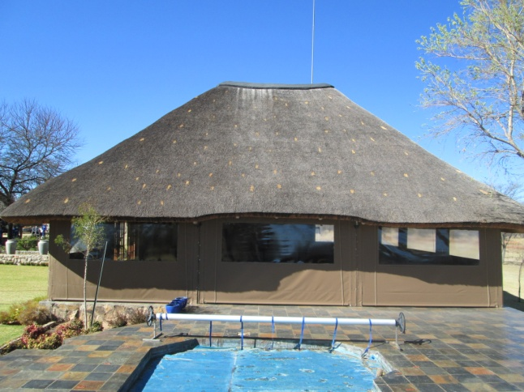

**Please feel free to contact me for an obligation free quotation.**.

Marius.

**083 589 1055**

[www.nellapas.co.za](http://www.nellapas.co.za)

E-mail: nellapas@mweb.co.za

nellapas7@gmail.com

